**Website Grader**

**Kufstein: This site is good**

Now let's take your site from good to great! See your scorecard below and take a Free Website Optimization Course to improve your grade.

Points:

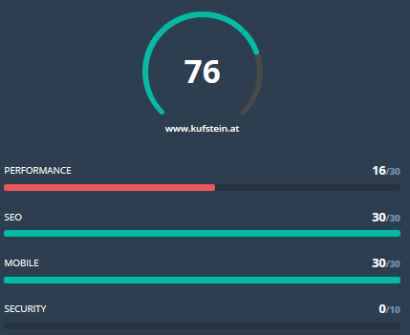

**Performance:** Optimizing your website's performance is crucial to increasing traffic, improving conversion rates, generating more leads, and increasing revenue.

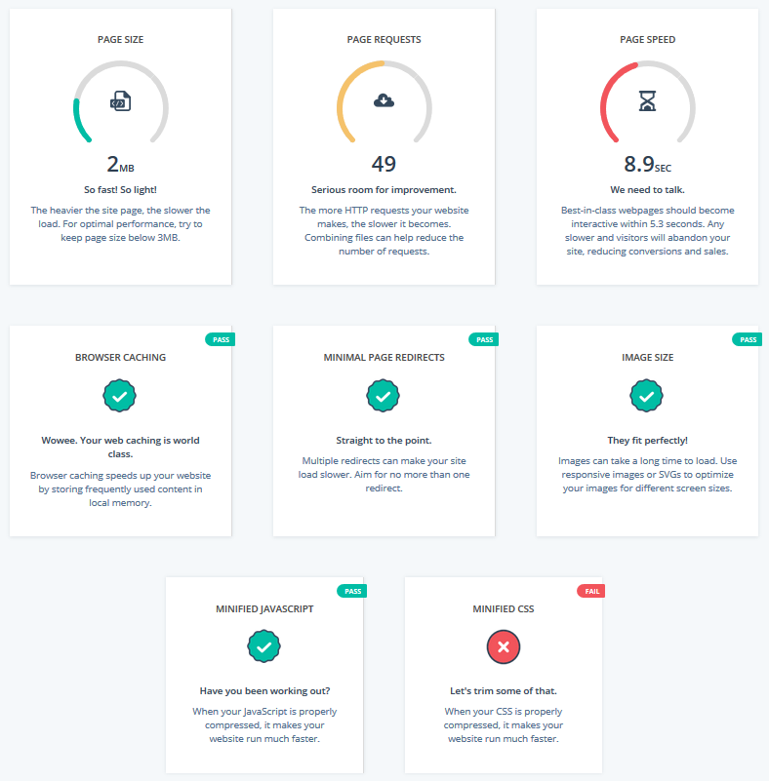

**SEO:** Optimizing your website content for search helps you drive organic traffic to your website. You can do this by providing a great experience for people and web crawlers alike.

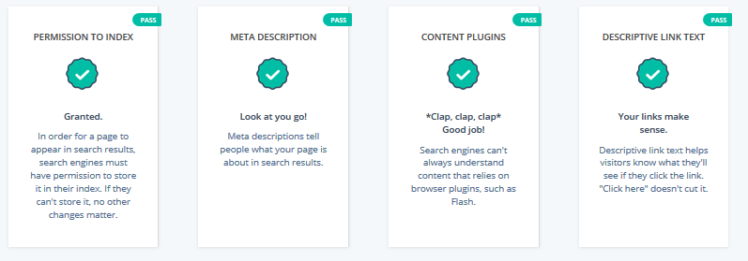

**Mobile:** Traffic from mobile devices is growing fast. Optimize your website for mobile or you'll miss out on valuable traffic, leads, and revenue.

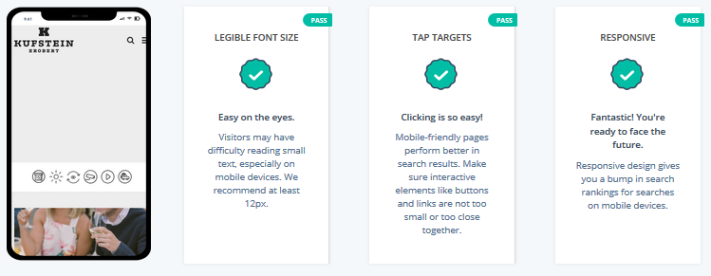

**Security:** A secure website equipped with an SSL certificate and free from vulnerabilities is now the standard online. People and search engines love secure websites.

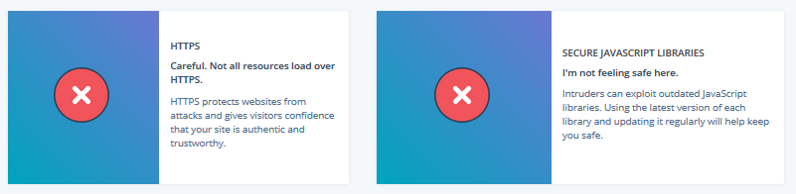

**Fazit**

